Holy Week Boxes
https://camillelebronpowell.wordpress.com/2013/03/18/holy-week-box/
- All of the supplies can be found at a regular craft store: cardboard box with lid (approximately 2″x2″x3″), marker, white fabric, green paper, scissors, simple wooden doll (they came in a bag of 12)
- Cut the green paper to resemble 2 or more palm branches. Shout “Hosanna! Blessed is He who comes in the name of the Lord! Hosanna!” and tell the story of Jesus’ triumphal entry into Jerusalem.
- Maundy Thursday- draw a simple cup and loaf of bread on the lid of the box. Jesus stands at the table and shares the meal with his disciples. We remember how he told us to do the same.
- Good Friday- draw a simple cross on the back of the box. You can talk with children about how sad all of Jesus’ friends were that day.
- Cover Jesus with the grave cloth and place him in the tomb
- Easter! The tomb is empty! Tell the story of the great news that when Jesus’ friends went to visit his tomb it was empty. Christ is risen! He is risen, indeed!
- Then pack it away to use again next year.
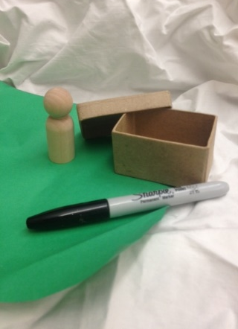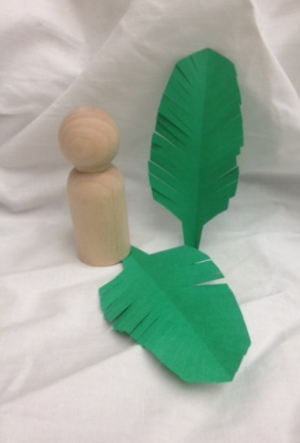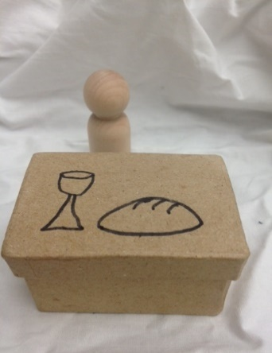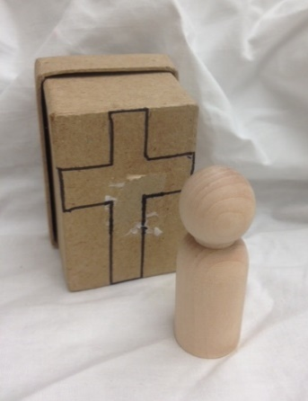
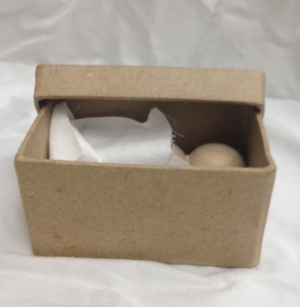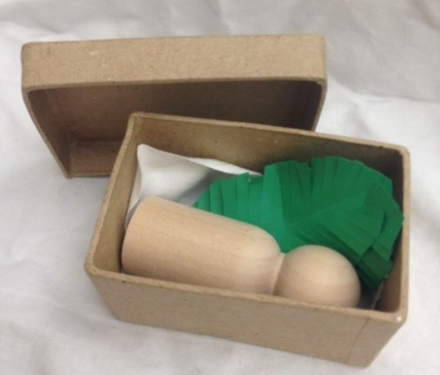
A song you could sing with children for Good Friday and Easter is a classic Piggyback Song, sung to the tune of “Are You Sleeping?”
Here’s the cross. Here’s the cross.[make cross with your fingers]
Jesus died. Jesus died. [use finger to make tears fall from your eyes down your cheeks]
See the tomb. [cup hands together to make tomb]
Empty tomb. [open hands to reveal empty tomb]
He’s alive! He’s alive! [clap to the beat]

